**Competitive Shooters of Lake Norman USPSA October 9, 2025**

**COURSE DESIGNER:** Rocky Perillo

|  |
| --- |
| **START POSITION: See written stage briefings.** |

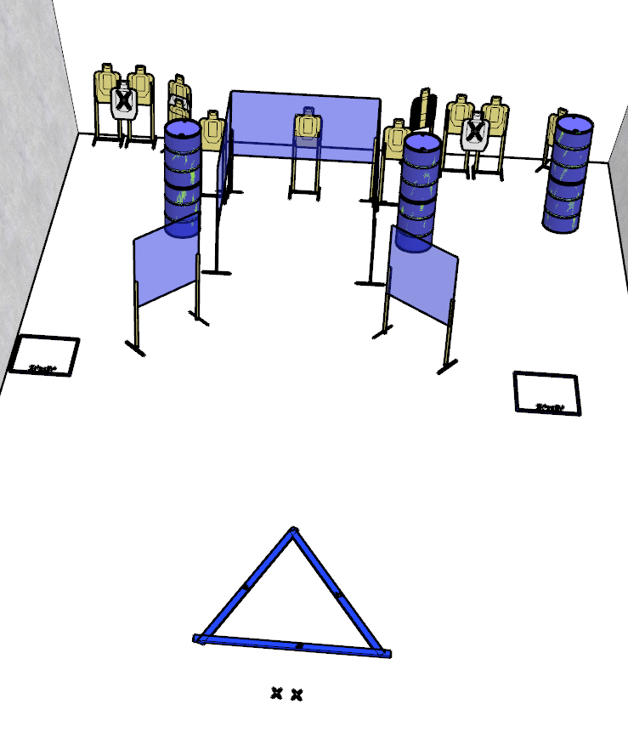

**Written Stage Briefing:**

**Stage 4 – Abby Normal-** is a 22-round, 110 point, Comstock Course. There are 11 cardboard targets and some noshoots. The best 2 hits per cardboard target will be scored.   
**Handgun start position** Both feet on the Xs. The handgun is **loaded** and holstered. Both palms touching top of head.

**PCC start position** Both feet on the Xs. PCC is **loaded** with both writs above shoulders.

On the audible start signal, engage targets from within the shooting area.